**AI ASSISTED CODING**

**Assignment-4.2**

Name: S. Vrindha Reddy

HT NO.: 2403A51255

Batch No.: 11

**Task-1:**• Zero-shot: Prompt AI with only the instruction — Write a Python function to  
generate the Fibonacci sequence up to n terms  
**Expected Output-1**:  
• A working function without using any sample inputs/outputs.

**Prompt:** Write a Python function to generate the Fibonacci sequence up to n terms.

**Code:**

**Task-2:**• One-shot: Provide one example: Input: 100, Output: 37.78 to help AI generate a function that converts Fahrenheit to Celsius.  
**Expected Output-2:**• A correct conversion function guided by the single example.

**Prompt:** Example: Input: 100, Output: 37.78

Now write a Python function that converts Fahrenheit to Celsius**.**

**Code:**

**Output:**

**Task-3:  
•** Few-shot: Give 2–3 examples to create a function that extracts the domain name from an email address.  
**Expected Output-3:**• Accurate function that returns only the domain portion of an email (e.g., @gmail.com)

**Prompt:**

Examples:

'user@gmail.com' -> '@gmail.com'

'admin@yahoo.com' -> '@yahoo.com'

'info@openai.com' -> '@openai.com'

Now create a function to extract the domain name from an email address.

**Code:**

**Output:**

**Task-4:**• Compare zero-shot vs few-shot prompting for generating a function that checks whether a word is a palindrome, ignoring punctuation and case.  
**Expected Output-4:**• Output comparison + student explanation on how examples helped the model.

**Prompt:**

Write a Python function that checks whether a word is a palindrome, ignoring punctuation and case.

**Code:**

**Output:**

**Task-5:**

Use few-shot prompting with 3 sample inputs to generate a function that determines the maximum of three numbers without using the built-in max () function.  
**Expected Output-5**:  
• A function that handles all cases with correct logic based on example patterns.

**Prompt:**

Examples:

(3, 7, 5) -> 7

(10, 2, 10) -> 10

(1, 1, 1) -> 1

Now create a function to determine the maximum of three numbers without using the built-in max () function.

**Code:**

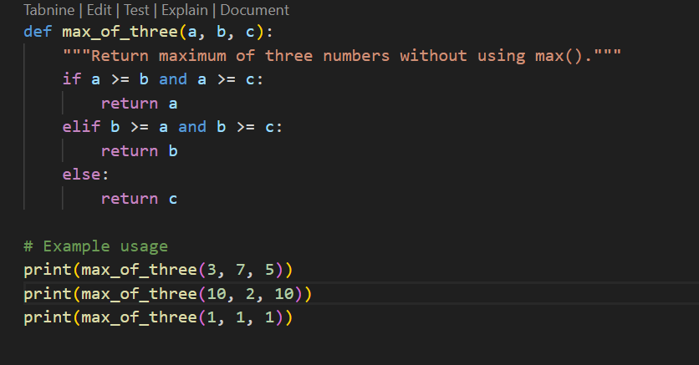

**Output:**

